ITMD 455-555 **Hello World example**

This is an exercise to get you started with updating your Android Studio after installation, choosing a Virtual Device (aka Emulator) and running your first app! If you experience any problems with updates, check the [troubleshooting](#ts) tips at the end of this document.

1. Start Android Studio. If you are presented with a splash screen as shown below, choose Start a new Android Studio project.

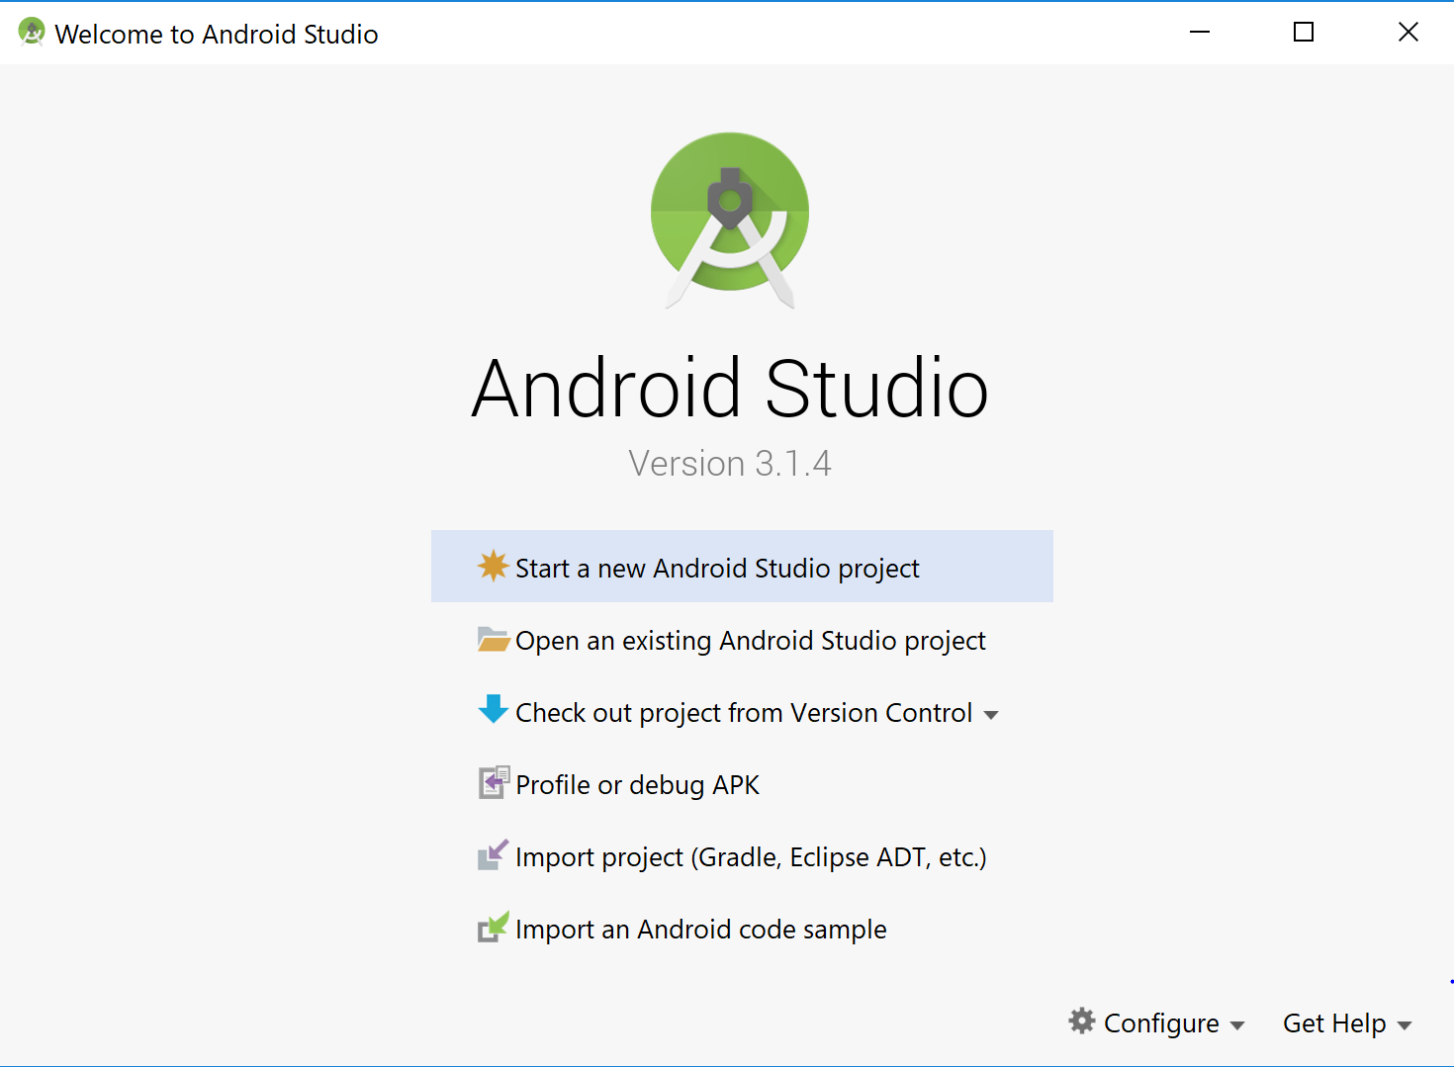

*Note*- if you ever see any Updates in your IDE (Integrated Development Environment) at start up, which may be pretty common, to be run from a notification as shown below, by all means click on the update link to run your updates to help sync Android Studio with some of the latest system images. Accept any agreements to continue.

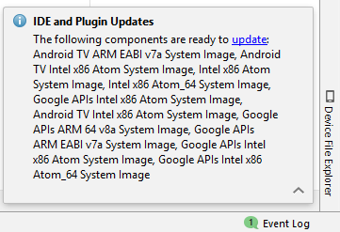

2. To run any application you want to have a Virtual Device set up. You may setup a device just once and use it for all your labs. From your menu choose **Run > Run ‘app’** as shown below.

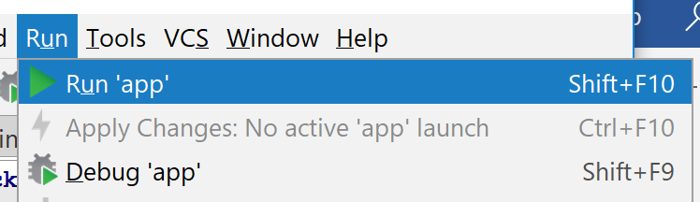

At the following pop up choose Create New Virtual Device as this is the first time you are running an app, and you need to specify or ‘choose’ a device to run your app on.

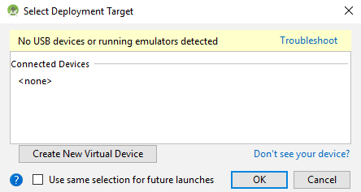

Choose a suitable device and press Next.

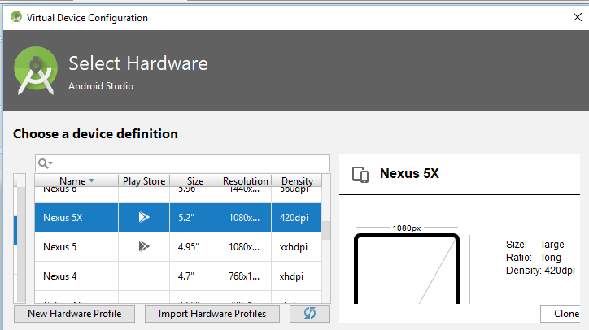

You will now need to download a suitable image to associate your Virtual Device with, so choose the *latest* API 28 image and click the Download link. Accept the License Agreement and choose Next to commence your download. ☺

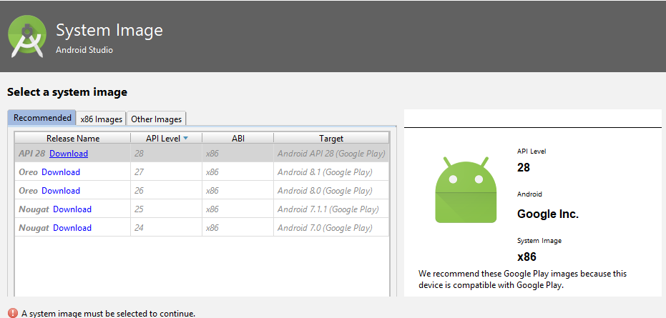

Note always see what is downloading to get a good understanding of image content, where things are downloading to (aka your **SDK path**), etc. Click Next to continue, then choose any name you like or leave the defualt Device name that now appears. Click Finish to end your setup.

Click OK at the Select Deployment Target window.

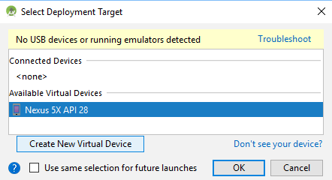

3. Okay we are ready to roll! Wait a few minutes for Gradle to finish its build and choose from your menu, **Run > Run ‘app’** again to see your app in action! Choose your available Virtual Device by selecting it (should now be the default) and choose OK.

[ *Note*, if you are getting any errors at this point, like ‘apk’ errors, it should be a simple fix. See [troubleshooting](#ts) tips section towards the end of the document ]

You should now see your build in action inside Android Studio within the Build windowed area!

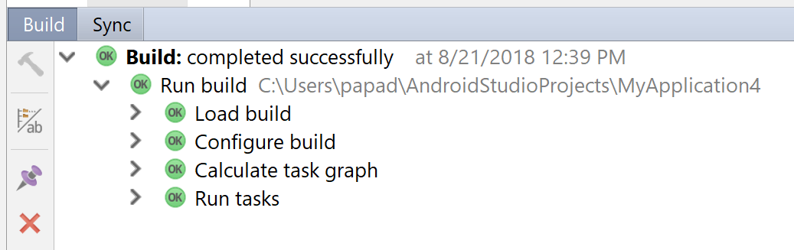

And voila! Your app has run! Congrats!!

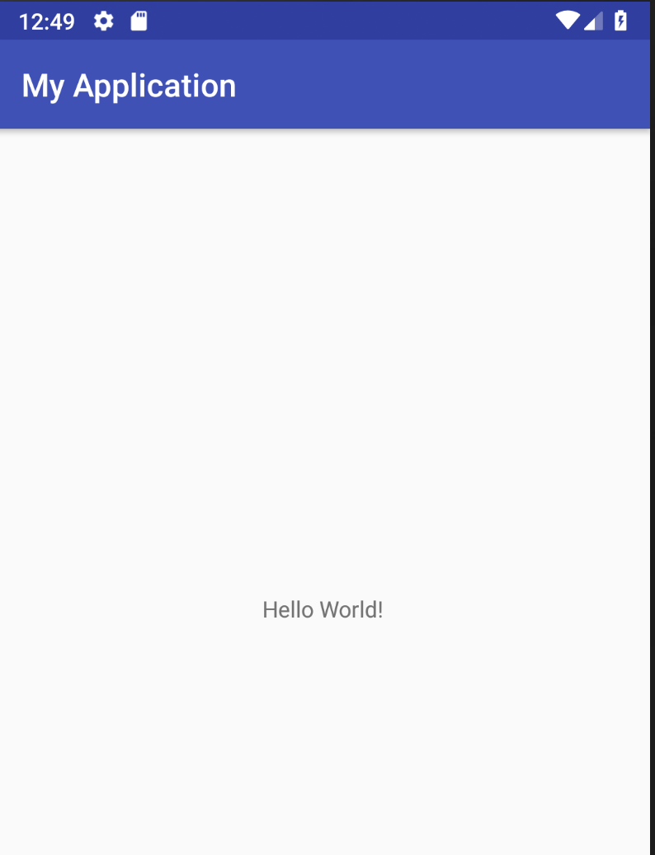

Further note, if you ever want to experiment with additonal device set ups, or “tweaks” to a current Virtual Device(s) you may have, go to Tools > AVD Manager.

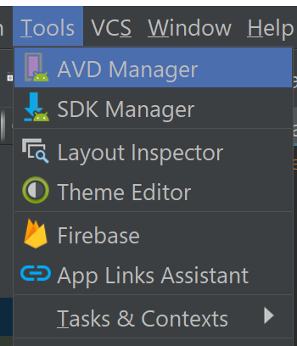

/var/folders/f_/p1nlxydx1rx8bnpg2v2w8zrh0000gn/T/com.microsoft.Word/Content.MSO/3CA950AD.tmp **Troubleshooting tips**

Sometimes you may get problems (a common issue) with builds and flags are thrown.

Common error message may say : **Error Installing APK**

This could be because either the code does not compile or Android Studio has failed to install the app.

Simple fix: Go to your menu and choose Build > Build APK(s).

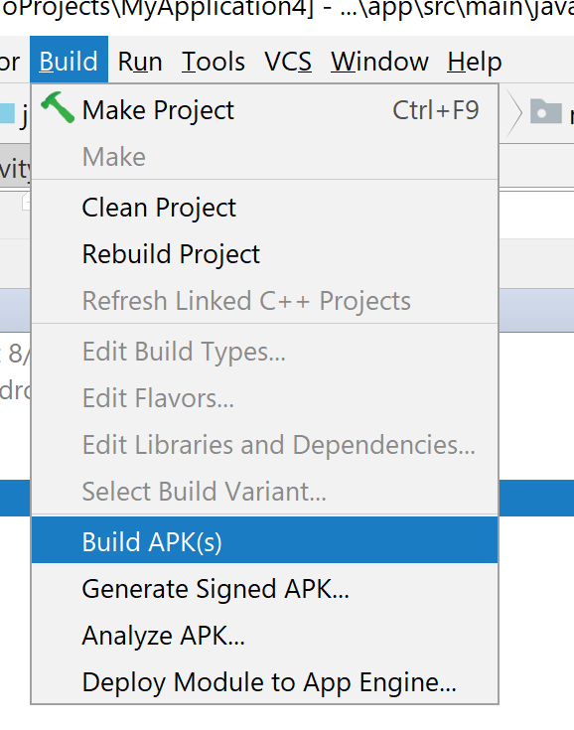

Then you should see a clearance.

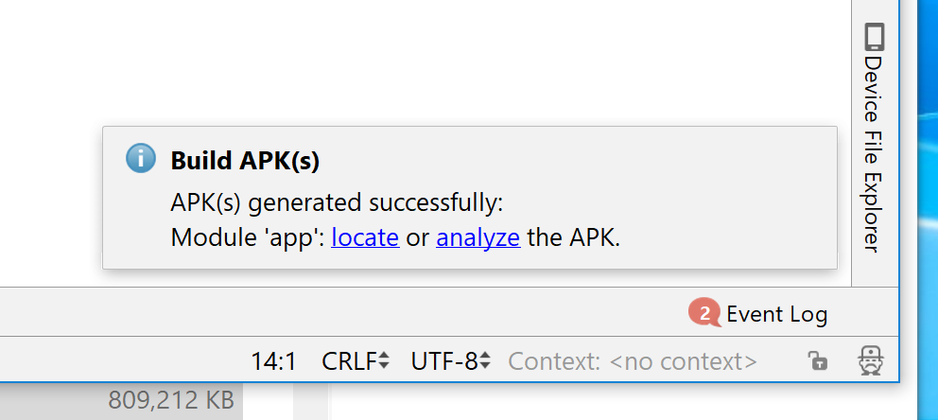

Now rerun your app and you should be good to go.

Other issues you may entail, are needed quickfixes of your SDK to comply with your devices, needed revisions, etc.

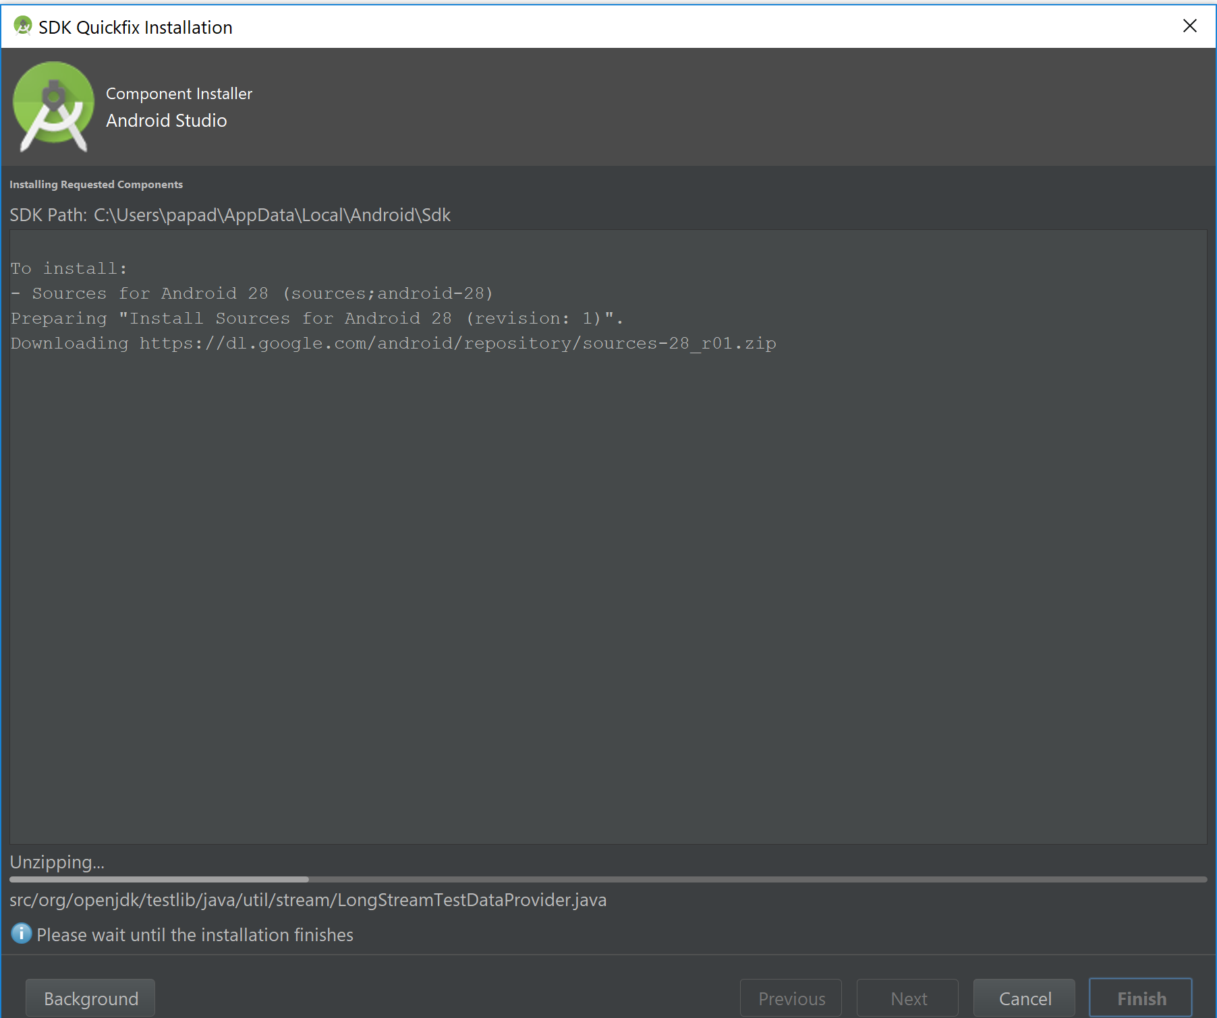

Process will take a few minutes…

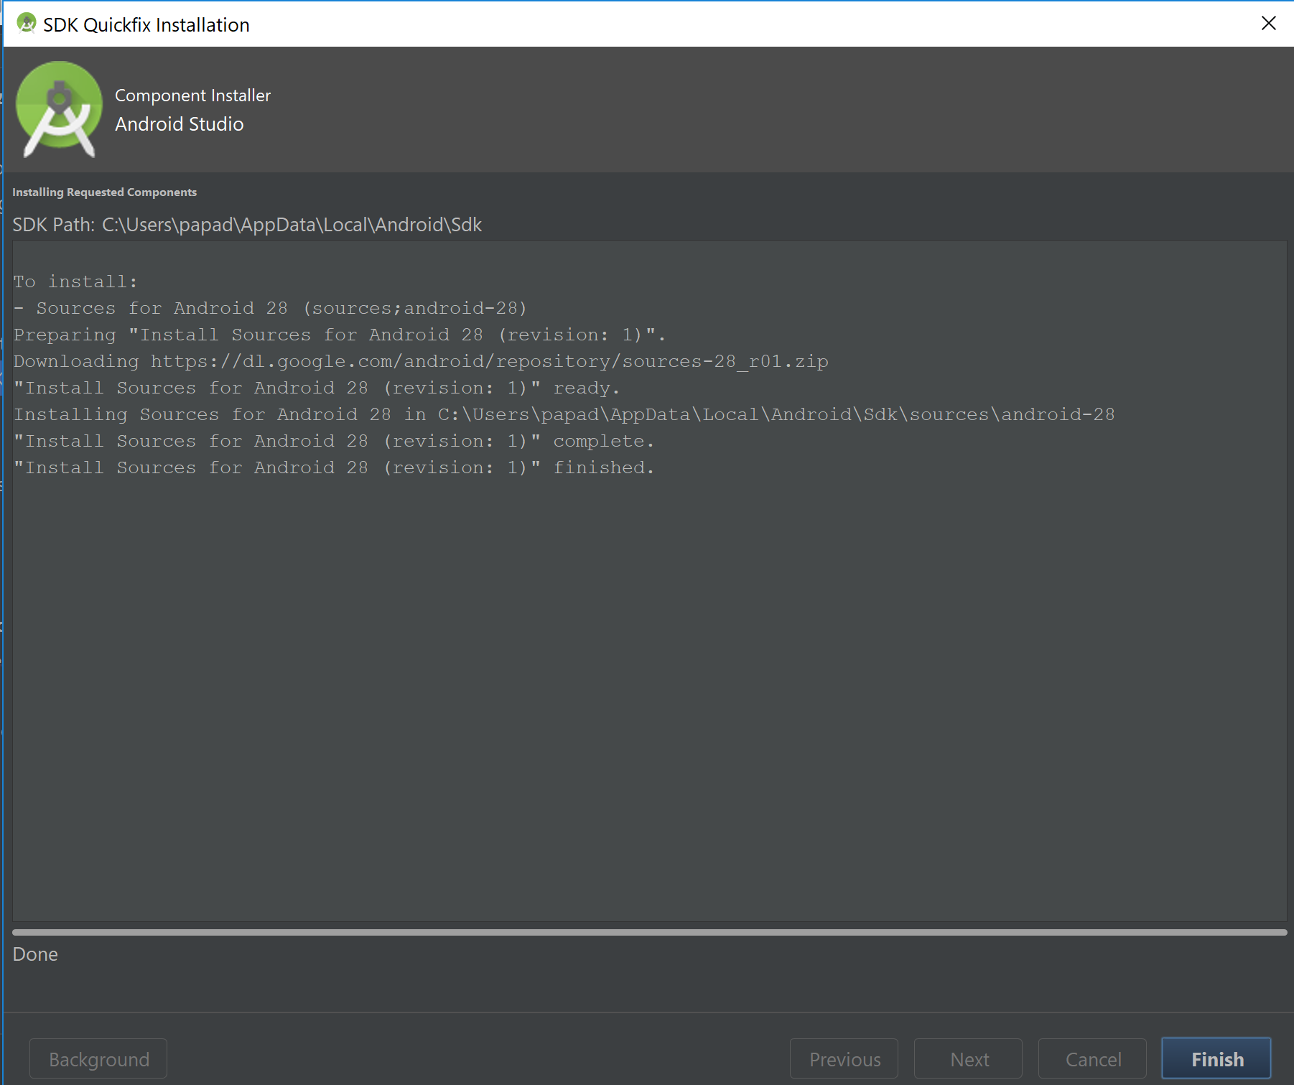

You can always go into your SDK Manager from your Tools menu, to take a “sneak peak” at revisions, latest builds, updates, packages that are loaded or ‘to be loaded’ etc.

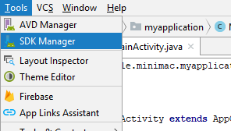

Gradle error example!

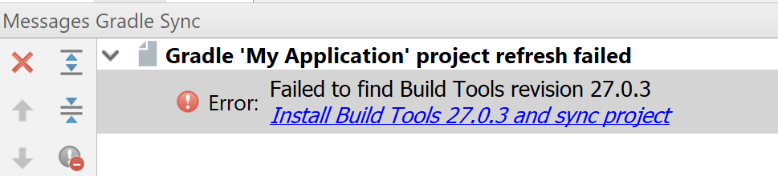

Could be pretty common to! Do the install thing to update things, system dependencies, etc.

That’s it for now.